Geography

6. Major Landforms of the Earth
Look out of your window and you will see buildings, trees, telephone poles and people. The world we live in now is shaped by people. The building you saw right there was constructed by someone, the tree planted by someone else and the poles by another. But people aren’t the only ones moving things around. Temperature, wind and rain do this all the time, creating shapes out of the Earth we know as Landforms.

Landforms
Weathering, water, elevation, sinking, and erosion of the soil are constantly shaping the surface of the Earth. It doesn’t really happen overnight but takes hundreds and thousands of years for us to notice these changes. These are the natural processes that lead to various formations of the Landforms. Landforms originate from these geological processes. Let’s understand the processes that shape the landforms.

External Process
External process means effects caused by the external factors such as rain or wind. Erosion occurs when material on the surface like soil and rocks which are called sediments are deposited or dropped off in a different location. These natural processes change the surface of the Earth. Erosion and Deposition are the processes that are occurring externally.

Internal Process
Needless to say, internal processes occur inside the surface of the Earth, beneath the crust. The internal process, like Volcanic eruption and Plate tectonics, are caused because of the intense heat in the Earth’s core that causes molten rock in the mantle layer to move thus creating uneven movement on the surface. These layers are either uplifting or sinking.
Landforms can be categorized into Mountains, Plateaus, and Plains depending upon their elevation and slope. Let us look at them individually.
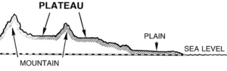
Source: wpclipart

Mountain
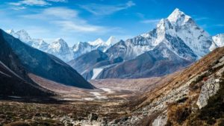
Source: Wikia
Any landmass that is higher and steeper than a hill is called a Mountain. A hill is a landform that extends above the surrounding terrain. Generally, mountains are higher than 2000 ft. In any other natural elevation like atmosphere, as you go higher and higher, the temperature drops down and the climate becomes colder. Habitation becomes harsher. That’s why there is less habitation in the mountainous areas.
Due to the temperature drop, it is not uncommon for mountains to develop ice on them. In some mountains, there are permanently frozen rivers of ice called as glaciers. Because of the steep slopes of the mountains, there is less land available for proper farming.
If the surface is calculated considering the sea base as the scale, there are mountains even under the sea. Mauna Kea (Hawaii) in the Pacific Ocean is an example. It is elevated higher than Mt. Everest. Also, a line of mountains is known as a range. For example, the Himalayas in Asia, the Alps in Europe and the Andes in South America. These ranges are the storehouses of water. Many rivers have their origins in these mountains, the glaciers of the mountains are the source of these rivers.
Mountains are generally untouched by civilisations are thus have the endangered species of plants and animals. They also inhibit a rich variety of flora and fauna. Mountains are further divided into three categories:

1. Fold Mountains
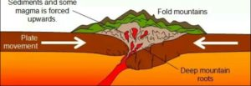
Source: Quora
Fold mountains are created when two tectonic plates collide and the edges of these plates ‘fold’ because of the enormous push force between them. Scientists classify the fold mountains into ‘young fold mountains’ are the ‘old fold mountains’ according to the mountains age.
- The young fold mountains are between 10 and 25 million years old such as the Himalayas in Nepal, the Alps in Europe and the Andes in South America.
- Now, the old fold mountains are older than 200 million years old such as the Aravalli mountains in India (Rajasthan) Ural mountain in Russia.

2. Block Mountains
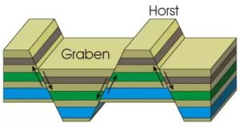
Source: Quora
Block mountains occur when large areas are broken and displaced vertically. These large areas of rock, sometimes stretching across hundreds of kilometres are created by tectonic and localized stresses in the Earth’s crust.
The uplifted blocks are termed as horsts. The lowered blocks are called grabens. They resemble piano keys. The examples of block mountains are the Rhine valley and the Vosges mountain in Europe.

3. Volcanic Mountains
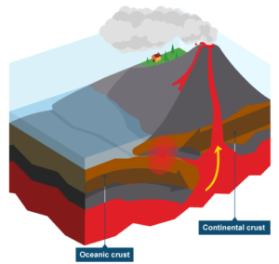
Source: HubPages
Volcanic mountains are formed by magma rising up from the mantle to the crust of the earth. The example of volcanic mountains is Kilimanjaro and Mount Fuji.

Plateaus
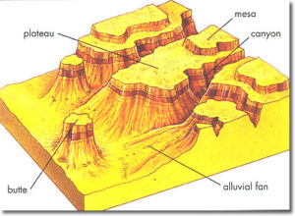
Plateaus are elevated flatlands. It is a flat land which is standing above the surrounding area. Plateaus may have one or more sides with steep slopes. Depending upon the plateau their height varies from a few hundred meters to several thousand meters.
The most familiar plateau in India is the Deccan Plateau and these plateaus are mainly formed by lava, meaning they are volcanic in origin. The extension of Deccan Plateau is the Chhotanagpur plateau in India. It’s a reserve for minerals such as iron ore, manganese and coal. African plateau is most famous for gold and diamond mining.
The Tibetan plateau is the highest plateau in the world. Plateau regions give birth to the waterfall, for example, Hundru falls in the Chhotanagpur plateau and the Jog falls in Karnataka. These plateaus are also centres for tourism and scenic activities.

Plains
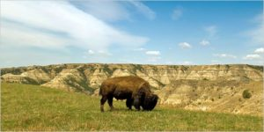
Source: NYTimes
Plains are the most fertile regions. They are stretches of large land. The predominant activity is the primary sector in plains which is A surrounding. These stretches of land are the most suitable for human habitation and agriculture activities like farming and poultry.
Plains are formed by rivers and their tributaries. The rivers flow down the mountains and erode them. They deposit sediments along their courses and in valleys. It is from these deposits that plains are formed. In India, the Indo-Gangetic plains are the most densely populated regions of the country. Where there is water, there is life.

